SCHOOL NAME: Liverpool Street Elementary
Address: 50 Liverpool St
Parent School Support Committee
Minutes
Date: Oct 21, 2021 Time: 6:15pm
Location: Microsoft TEAMS
PSSC Members Present:  Ronnie Stewart, Chair  Colin Curry, Vice Chair  Keri O’Leary, Teacher Rep.  Tara Swift  Bronwyn Mulherin-Murphy  Erica Fanjoy  Erin Wilson  Sabina Thapa  PSSC Members Regrets:  Asha Noel-Hart  Siddaiah Madadevaswamy | School/DEC Representation Present:  Kelly Parks, Principal  Jennifer Kelly-Milner, Vice Principal  School/DEC Representation Regrets:  Miriam MacLaughlin, DEC Rep
Call to Order: by Ronnie Stewart

Approval of the Agenda:

- Approval of the Minute: Motioned by Ronnie Stewart, seconded by Tara Swift
Business from Previous Meeting:
- Dumpster and Community Bins - Sept 25- Mme Parks spoke with community Living, who was at the school to collect donations in the community bin. They volunteered to take the items to the dump for the school. A donation was to Community Living was made by Mme Parks to thank them for their kind offer.

Oct 1st- contacted community Living. Orange bin was removed on Oct 1, 2021. Kelly Parks called Boys and Girls club to discuss possibility of where dumpster could go. (Oct 1). A call was made to district facilities to ask what the parameters are for dumpster- (Oct 1). District has allowed the school to have 2 pick-ups weekly to help alleviate the build-up of things around the dumpster. Collection will be on Monday & Thursday’s. Due to this increase in pick up, the lock has been removed from the dumpster. Call was made to Children’s wish grey bin organization- (Oct 1)- waiting to hear from organization. The City of Fredericton by-law officer contacted the school to say the community had been complaining about the abundance of trash around the bins. All bins have since been removed.
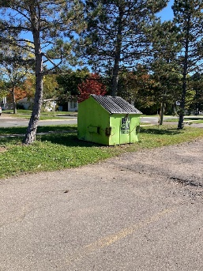
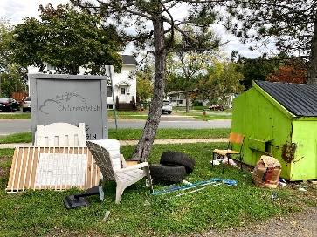

- Busing- Our busing for Liverpool is going well. Things seem to have sorted themselves out.

- Odd Items found on school grounds (luggage) – City police were contacted as there have been break-ins reported in the surrounding community. The officer came to collect the luggage and a bike that had been on school property for quite some time. They hope to find the owners.

- Where to place Dumpster on school grounds – policy is that the dumpster must be 20 ft away from the building so this poses a bit of a conundrum of where to move it to. As well, if we move it to the front of the building, then custodians have to travel farther to dispose of the garbage. Hope is that with 2 pick ups weekly, we will not need to move the dumpster now.

- Fundraiser- Epicure $900.00

- Home and School Committee (Mrs. Kelly -Milner) – difficult to get members schedules to line up so a meeting can be held. They have decided to do a Christmas basket fundraiser again this year (gift card, family night in, family night out, pampered self) and they are looking into a possible Seed campaign for the spring. Calendars will go on sale in November and we are hopeful for the same success as last year.

- PSSC Budget - $ 892.17 – Ronnie would like to see this used for bringing the community back into the school post-Covid. Can also be used for PL for members, to send reps to DEC symposium, bring in speakers to the school, etc. Will discuss more later and decide at that time.

- meditation for students – Sabina spoke about the need for improved focus on mental health of students during times outside of Phys. Ed. Mme. Parks said that a lot of mental focus is already happening daily in our classrooms and with our Guidance teacher Miss. Bass but we can definitely look into ways to add time to this.

Business Arising from the Minutes:
(New Business / agenda):

- Covid 19 – Erin was asking about rapid testing kits at home and had a concern with confidentiality when students are returning them to school and the possible stigma attached to them. Mme. Parks said that the students are quite resilient with them, as they are with masks, and there is really no notice of who brings one in and who doesn’t among the students. Mme. Parks also noted that if parents preferred, they were able to take a photo of their test at home and email it in rather than bring it in person.
- Weekend positive cases – why were we not notified? – There is a new policy with testing where some cases are not deemed a school case if they have been home for 2 days and not in school. Rules are changing as public health learns more and our school is trying to stay on top of it the best we can.
- Close contact – how are you contacted? – again, another change to the procedure. Now if you are deemed a close contact you will receive an email telling you how long you must isolate/ self monitor for. However, some people may still get a phone call.

- Principal Report:
Principal Report October 21, 2021
- Apple Field trips- Grade 2, Grade 3 and Grade 4 went to Riverview Apple Orchard for wagon ride, corn maze and apples. Grade 5 went to Everette’s Apple Orchard for wagon ride, apple picking and learning about their animals at the farm. Classes that were isolating during these field trips are looking into alternative outdoor trips.
- Orange Shirt Day-
- Activities school wide:
-Morning announcements – played the wolastoq song
-Books shared in classroom- I lost my talk and I’m finding my talk.
-Discussion on what is Orange shirt day? Why do we wear Orange on Sept 30?
-Photos of classes in orange
Classroom activities:
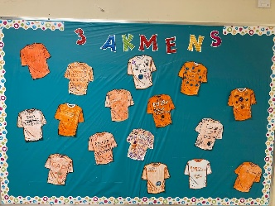
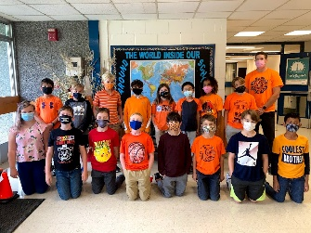
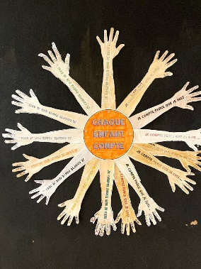

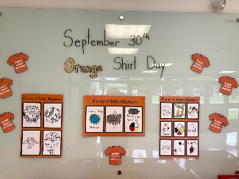

- PLP-PL for teachers given by resource on ESS Connects
- PL- For grade 2 teachers on module 2 for reading benchmarks
- Parent Portal- for attendance right now, but will eventually move to report cards and marks
- Pumpkin drop – Oct 29 at 11:00
- Pumpkin decorating
- Safe Schools Week- so far, we have practiced fire drill, bus safety and bus evacuation, lock down and tomorrow is evacuating the school.
- Calendar Fundraiser- to begin next week
- Report Cards go home Nov. 29
- Nov 19- pl day for teachers – no school for students
- Positive Workplace Framework Survey- Mental Fitness Overview:
-Embedded and building. Nothing in Awareness(targeted)
- New games for students purchased
- Oct activities for teachers to do with students- glow sticks, funny fingers for reading, new read alouds for Fall in both FI and English/ Orange shirt books/
- Smoothie day- Monday for Grade 2+3, Tuesday 4+5
- Strike possibility – all custodians, EA’s, bus drivers and admin assistants will be affected.

Correspondence/Action Items: An attempt will be made to contact Miriam MacLaughlin so that we can discuss the DEC, their thoughts and path they are taking this year. We are hopeful she is able to attend the next PSSC meeting.

Closing Comments:

Date of Next Meeting: November 18, 2021

Adjournment: 7:15pm

Motioned by Ronnie Stewart, seconded by Colin Curry

